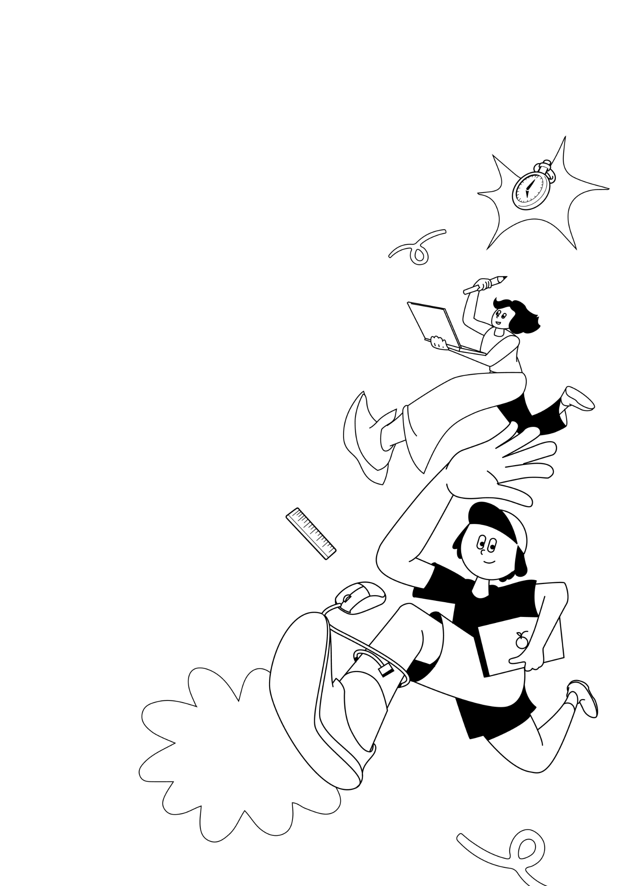
LKSN 2024

TEKNOLOGI
DESAIN GRAFIS

Module X (EN)
Topic

LKS Nasional
AGUSTUS 2024

CONTENT
This module consist of these content:
File : Module X
Folder : Module X_Assets, Module X_Images

INSTRUCTION FOR COMPETITOR
- Learn the topic that have been given.
- Do the next instruction based on the topic.

TOPIC
Brand Name : Boeng, Ajo Boeng! Museum
Brand Slogan : Historical Poster Museum of Indonesia

INTRODUCTION
Museum Boeng, Ajo Boeng! in Central Jakarta, established in the 1980s, is a unique institution dedicated to preserving and showcasing historical propaganda posters from the period before Indonesia's independence. These posters, created during a time of intense struggle, were essential in rallying the Indonesian people and supporting the efforts of guerilla fighters against colonial powers. The museum's name, "Boeng, Ajo Boeng!"—a call to action meaning "Come on, Let's Go!"—reflects the spirit of resistance and determination that these posters encapsulated. By curating these powerful visual artifacts, the museum offers visitors a window into the creative and strategic ways in which art was used to inspire unity and foster a sense of national identity during a critical period in Indonesia's history.

The museum's main goal is not only to archive these significant pieces of history but also to educate the Indonesian public about the sacrifices and efforts made by the guerillas in the fight for independence. Through its extensive collection, Museum Boeng, Ajo Boeng! provides an educational experience that emphasizes the importance of remembering and understanding the past struggles for freedom. The museum plays a crucial role in ensuring that the legacy of Indonesia's independence movement is preserved and passed down to future generations, fostering a deeper appreciation for the resilience and courage that led to the country's liberation from colonialism.

PROJECT DESCRIPTION AND TASKS
To support this exhibition, a visual identity system is needed to be applied across various promotional media for the Boeng, Ajo Boeng! Museum.

TARGET GROUP
Age : 18-45 years old
Gender : Men dan Women
Social Class : Middle-up class
General Behavior : Tourists, Historians, Student, Family, and Artist.

